TECHNICAL INFORMATION
FOR PROFESSIONAL USE ONLY

SHIELD  2K POLYURETHANE PROTECTIVE COATING 3:1 |  |  |  | 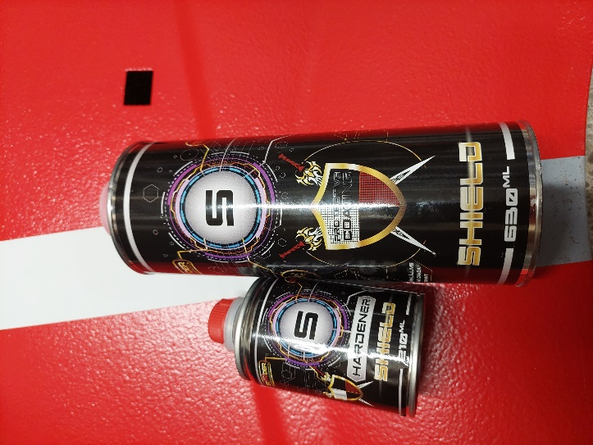
PRODUCTS
SHIELD - 2K polyurethane protective coating Hardener for SHIELD
STONDER Acrylic Thinner
PRODUCT DESCRIPTION
2-component polyurethane protective coating with a structured effect. The product has excellent chemical (oil, gasoline, water, salt) and mechanical resistance (scratches, stains). Resistant to weather conditions (UV filters) and corrosion (anti-corrosive agents). Can be applied on a various of substrates. It can be applied with the UBS antigravel gun as well as with a conventional gravity spray gun.
 |  |  |  | COLOR: black, tintable
VOLATILE ORGANIC COMPOUNDS
VOC for the mixture using an UBS gun = 389 [g/l]
VOC for the mixture using a gravity feed gun (3:1+20%) = 530 [g/l]
The share of VOC for the mixture is below 840g/l. These products fulfill the EU directive (2004/42/WE) that sets the VOC value for this product category (kat.B/5), as 840 g/l.
SURFACE PREPARATION
- Existing 2K coatings – exercise caution and conduct a solvent test to check the quality condition of the substrate.  - Always abrade, clean and degrease the surface before application.  - Do not apply the product on 1K primers. Instead, always prime the surfaces for the Shield application with a 2k acrylic primer, 2K epoxy primer or 2k etching primer.  - Always wait the proper drying and hardening time of etching primer before application.  - Do not apply Shield directly on bare original paint or directly on coatings of car body parts from the aftermarket. |  | Substrates:  - Steel, galvanized steel, stainless steel, aluminum - apply after pre-sanding the surface with sandpaper of grade P180 to P320 or cleaning the surface with abrasive blasting to a cleanliness level of Sa 2 ½ according to PN-ISO 12944-4.  NOTE: To increase anti-corrosion protection and adhesion, it is recommended to apply Shield over epoxy or reactive primers (wash primer).  - Polyester laminates – sand using abrasive paper P180 or by using unwoven  abrasive fabric (Scotch brite), clean and degrease (Stonder Silicone Remover).  - Polyester body fillers - sand using abrasive paper with gradation from P120 to P240, clean and degrease (Stonder Silicone Remover).  - Plastic surfaces - degrease (Stonder Silicone Remover), sand with abrasive paper P240 or with unwoven abrasive fabric (Scotch brite), degrease again (StonderSilicone Remover), prime with an adhesive promoter, such as Stonder Plastic Primer. Due to the many different types of plastic, adhesion testing is advised.
APPLICATION
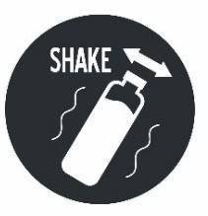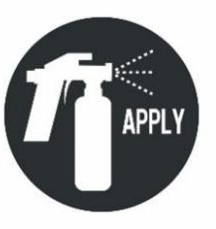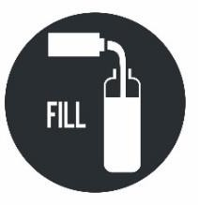 |  |  | UBS |  | CONVENTIONAL GUN
 | Mixing ratio |  | 3:1 |  | 3:1+10÷20%
 | Nozzle |  | - |  | 1.4÷2.5 mm
 | Inlet pressure |  | 2÷4 bar |  | 2 bar
 | Distance |  | 20÷50 cm |  | 20÷50 cm
 | Number of layers |  | 2 |  | 2
 | Flash off between layers |  | 30÷50 minutes |  | 30÷50 minutes
 | Ready for assembly |  | 3 days |  | 3 days
 | Through dry (severe conditions) |  | 7 days |  | 7 days
 | Efficiency |  | 2,5÷3 m2 |  | 3,5÷6,5 m2

APPLICATION PROCESS SHIELD BLACK/FOR COLOR
UBS Gun
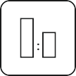 | MIXING RATIO 3:1 | by volume | by weight |  | POT LIFE
 | SHIELD 630 ml 790 g  Hardener 210 ml 210 g Shake the product before opening. Open the lid, add hardener  and close back the lid. Shake very well. |  |  |  | about 1 h at 20oC
 | DRYING TIME
Dust dry: 1 h/ 20°C
Touch dry - ready for assembly: 3 days/ 20°C Through dry (severe conditions): 7 days/ 20°C
Temperatures below 20°C significantly increase the hardening time.
 | BAKING
In order to accelerate the physical drying time we recommend baking under a maximum temperature of 45°C for 50-60 minutes. Before baking wait the appropriate evaporating time of 1,5 to 2 hours after application.
ATTENTION! Baking does not accelerate the dry through time. It is recommended to wait 7 days to achieve total hardness of the
coating (under severe conditions).
 | NUMBER OF LAYERS
2 layers - 1 dry layer of approx. 150µm.
- First layer – spray evenly with sweeping motion and pressure of 2-4 bar until the proper coverage is obtained. The distance from the surface to be painted should be of 50cm.
- Allow to flash off for 30÷50 minutes between coats.
- In order to obtain the desired texture reduce the pressure and increase the distance from the surface to be painted. To achieve fine texture, apply the second layer with a fine mist spray by reducing the pressure and material flow. The distance from the object and pressure change the created structure.
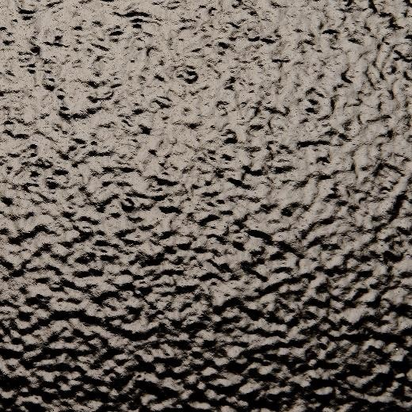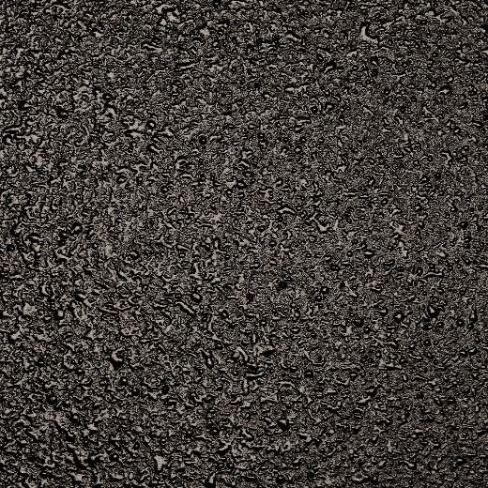

APPLICATION PROCESS SHIELD BLACK/FOR COLOR
GRAVITY FEED SPRAY GUN
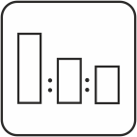 | MIXING RATIO 3:1 | by volume | by weight |  | POT LIFE
 | SHIELD 630 ml 790 g  Hardener 210 ml 210 g  Thinner 84÷168 ml 74÷148 g  Shake the product before opening. Open the lid, add hardener and close. Shake very well. Add thinner and shake again until all elements have been incorporated. |  |  |  | about 1 h at 20oC
 | DRYING TIME
Dust dry: 1 h/ 20°C
Touch dry - ready for assembly: 3 days/ 20°C Through dry (severe conditions): 7 days/ 20°C
Temperatures below 20°C significantly increase the hardening time.
 | BAKING
In order to accelerate the physical drying time we recommend baking under a maximum temperature of 45°C for 50-60 minutes. Before baking wait the appropriate evaporating time of 1,5 to 2 hours after application.
ATTENTION! Baking does not accelerate the dry through time. It is recommended to wait 7 days to achieve total hardness of the coating (under severe conditions).

NUMBER OF LAYERS
2 layers - 1 dry layer of approx. 50µm
Parameters for gravity feed gun
Nozzle: 1,4÷2,5 mm; Inlet pressure: 2,0 bar.
- First layer – spray evenly with sweeping motion, pressure of 2 bar until the proper coverage is obtained. The distance from the surface to be painted should be of 40 cm.
- Allow to flash off for 30÷50 minutes between coats.
- In order to obtain the desired texture reduce the pressure and increase the distance from the surface to be painted.
To achieve fine texture, apply the second layer with a fine mist spray by reducing the pressure and material flow. The distance from the object and pressure change the created structure.
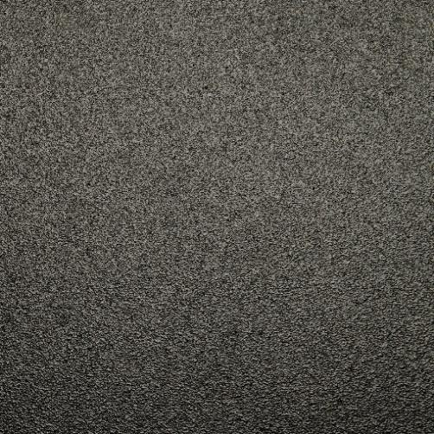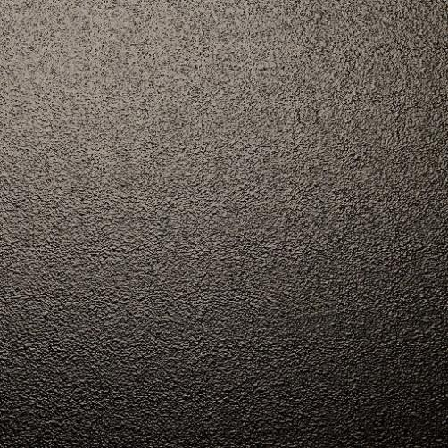

SHIELD FOR COLOR
Color can be added to the tintable Shield version with the addition of diluting products (for the whole mixture)
- Acrylic solvent borne basecoat toner- 5÷10%
- Acrylic solvent borne basecoat- 10÷15%
- Acrylic solvent borne topcoat- 10÷15%
RANGERS BLACK/FOR COLOR
Rangers can be over coated. Wait 24 hours for the product to dry. Abrade surface with fine unwoven abrasive fabric (Scotch brite), clean and degrease (Stonder Silicone Remover).

SHIELD BLACK/TINTABLE |  | HARDENER
ml | g | ml | g
210 | 263 | 70 | 70
315 | 395 | 105 | 105
630 | 790 | 210 | 210
1260 | 1580 | 420 | 420
1890 | 2370 | 630 | 630

GENERAL NOTES
- Do not exceed recommended doses of hardener!
- The best results can be achieved at room temperature. The temperature in the body shop and the temperature of the product should be similar.
- When working with 2K products, it is recommended to use personal protection equipment. Protect the eyes and respiratory system.
- The rooms should be well ventilated.
- Clean the guns and equipment immediately after use.
Caution: To maintain safety, always follow the instructions given in the MSDS for the products.
STORAGE
Store the product components in temperatures of 15 to 25 oC, in a sealed container, in dry and cool places, away from fire and heat sources, as well as direct sunlight.
Note:
- Immediately close the tins after each use!
- Protect hardener against freeze and humidity!
WARRANTY PERIOD
SHIELD - 2K polyurethane protective coating Hardener for SHIELD | - 12 months from the date of production  - 12 months from the date of production

OTHER INFORMATION
The effectiveness of our systems results from laboratory research and many years of experience. The data contained herein meets the current knowledge about our products and their application potential. We ensure high quality, provided the user follows the instructions and the work is performed in accordance with good workmanship. It is necessary to do a test application of the product due to its potentially different reaction with different materials. We may not be held liable for defects if the final result was affected by factors beyond our control.
RAGS Ltd. Reg. No.: 40003133752, VAT number: LV40003133752
Legal address: Durbes iela 8, Rīga, LV-1007,
Actual address: Džūkstes iela 1, Rīga, LV-1004
Tel. +371 67 808 780, +371 26 542 777

